project plan

|  |
| --- |
| Z 7layersF:\Fontys\prop\old\pp.jpg |
| **Version**: 1 - week 3   * **Date**: 22-4-2019 * **Tutor**: Mikaeil Shaghelani Lor * **Client**: Emin Thaqi  **Group members:** Mohamad Wissam Alhamwi – Dimitrije Guteša- Radu Pavel- Borislav Pavlov **Version Table**   |  |  |  | | --- | --- | --- | | Version | Date | Working on : | | 1.0 | **06-02-2019** | **Project plan draft** | | 2.0 | **13-04-2019** | **Adding subtitles till phase 1** | |  |  |  | |

**1-Project Statement……………………………………………………………………………....**

**1.1Formal Client……………………………………………..………………........................**

**1.2 Project Leader.…………………………………………………………………….......….**

**1.3 Current Situation………………………………………………………………………….**

**1.4 Problem Description…………………………………………………………….............**

**1.5 Project Goal………………………………………………………………………………..**

**1.6 Project Deliverables and Non-Deliverables………………………………………….**

**1.7 Project Constraints……………………………………………………………………….**

**1.8 Project Risks……………………………………………………………….………...........**

**1.9 Project Phasing……………………………………………………….………..................**

**2-Project Phasing…………………………………………………………………………………..**

1. **Project statement:**

In this document, we will describe all process and steps and how we plan to do the project

the structure is divided into the following subjects:

the formal client, the project leader and the team, the current situation, the problem description, the project goal, the deliverables and non-deliverables, the constraints and the risks.

**1.1** **Formal Client:**

Our client is Mr. Emin Thaqi, he has a company that organizes an international music festival every year and he has contracted our company to implement a software solution for this event

**Contact Information:**

* **Name:** Mr. Emin Thaqi
* **Company:** Fontys Hoge school ICT
* **Address:** Rachelsmolen 1, 5612 MA Eindhoven
* **Room** R1 2.40
* **Email:** [e.taqhi@fontys.nl](mailto:e.taqhi@fontys.nl)
* **Phone nr**: 088 508 70 02
* **Mobile nr:** 06 108 52 870

**1.2 Project Leader:**

The team leader of the project is Borislav Pavlov. The leader will provide guidance, instruction and direction to the all members of the group and also will ensure everyone to do their work.

**1.3 Current Situation**

The situation that led our client to our service is the lack of control and management of music festivals he’s company organizes. As the popularity of his festival increased, more and more people started to get interested in it which lead to much larger live audience. He found It hard to manage all the users coming to him and to pay all the staff responsible for the organization and maintenance. Our client hopes that we will help him reduce the cost of organizing these events an also maximize his profit by introducing new business models with banks and renting companies. The accent was on the identification problem of a large-scale group. He wants to make sure that everything will run smoothly and is easy to apply and have fun on his festival.

**1.4 Problem Description**

The main reason our client needed our help is to solve the problem of managing a large-scale event. With the increase of interest in his festivals he needs a long-term solution for keeping track of large group of people within the festival. Big part of his problem is Identification of the users and their actions from the moment they get a ticket until they log out.

**1.5 Project Goal**

The goal of this project is to develop and implement the software solution for our client’s problem. This software should cover all of our client’s requirements and hopes. Our goal is to maximize the simplicity of applying for the festival and managing the people who are attending. Profit increase is desirable.

**1.6 project Deliverables and non-deliverables**

**Deliverables:**

* + - A website that is able to sell tickets for this event and also provide information about the line-up.
    - An application that keeps the record of the visitors checks in and out of the event and camping
    - An application that allows the maintainer to check the live status overview of the whole event (ADMIN PANEL)
    - An application to sell food/drinks/souvenirs
    - An application for loan stands
    - Agenda with minutes of every meeting
    - A database supporting all the applications and website
    - An application to check, deposit and withdraw money based on ATM log files
    - Process records
    - A design document of this event

**Non-deliverables**

* + - A real ATM machines
    - A translation of the website in different languages
    - A manual of the applications

**1.7 Project constraints**

* + - Time: We have to finish the project in 14 weeks, until the end of the second semester
    - Programming language: The Windows applications should be programmed in an object-oriented language with which all members are familiar, e.g.: C#. The application has to obey the principles of the object-oriented approach.
    - Sharing documents: Our documentations have to be shared to our tutor and client using GitLab
    - Every week there is a meeting with the group and the tutor. There should be an agenda and you should make minutes of every meeting. The agenda should be distributed at least one working day before the meeting. Minutes should be distributed at most one working day after the meeting
    - The website should run on the Iris server of FHICT. We have to use the technologies learned in WEB1 and WEB2.

**1.8 Project risks**

**1-Failing to complete all the project features on time**

* + - Probability: Medium
    - Impact: High
    - Prevention: Set up meeting every week to check on each other’s work

**2-A team member drops out**

* + - Probability: Low
    - Impact: Enormous
    - Prevention: More team communication

**3-Misunderstanding of the requirements**

* + - Probability: Medium
    - Impact: Medium
    - Prevention: Keep constant communication with the tutor and client

**4-Not being able to fully implement a deliverable**

* + - Probability: Medium
    - Impact: Medium
    - Prevention: Research and good documentation of every deliverable

**2-Project phasing**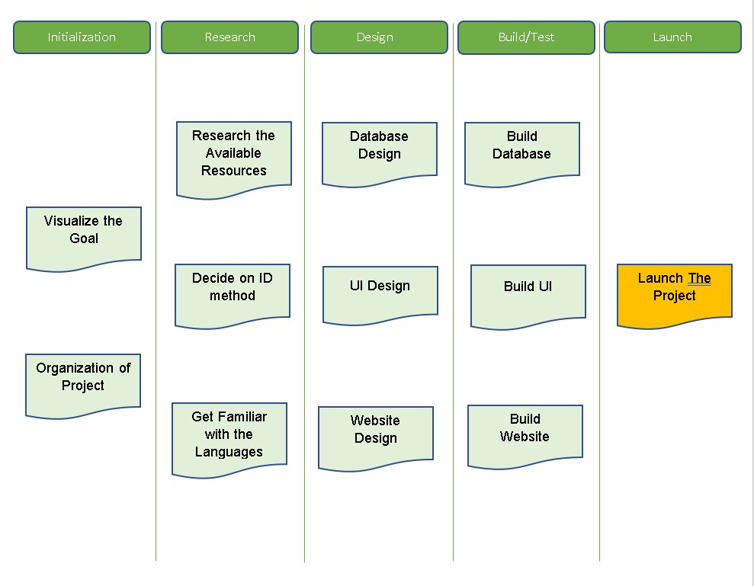

**PHASE 1: Initiation**

* + - Get familiarized with the idea of the project
    - Set a meeting with the client for more information
    - Create a name and logo for the group

**Deliverable**

* + - Draft of the project
    - Logo
    - Name